5.1 Experiment No. : 05
5.2 Experiment Name : Application of HTML Forms
5.3 Theory
This experiment demonstrates the use of HTML <form> elements for collecting and submitting user input in web applications. Forms serve as the primary method for interaction between users and websites, enabling tasks such as login, registration, searching, and data submission. The <form> tag provides a structured way to gather input through various form controls like text fields, checkboxes, radio buttons, dropdowns, and buttons.

Core Concepts
1. Structure of Forms
◦ An HTML form is created using the <form> element, which can include input controls such as <input>, <textarea>, <select>, and <button>.
◦ Each control captures a specific type of user input, e.g., text, numbers, passwords, or choices.

2. Attributes of the Form
◦ The action attribute specifies the server endpoint where form data is sent.
◦ The method attribute (GET or POST) defines how data is transmitted to the server.
◦ Additional attributes like name, id, and placeholder enhance usability and identification.

3. User Interaction and Validation
◦ Forms provide a structured way for users to enter data that can be validated both on the client side (using HTML5 validation or JavaScript) and server side.
◦ Proper validation improves data accuracy and security.

4. Separation of Structure and Functionality
◦ HTML handles the structure of form elements, while CSS is used for styling and layout.
◦ JavaScript can add interactivity, dynamic validation, and real-time feedback.

Advantages of HTML Forms
• Provides a standardized method for collecting and transmitting user data.
• Supports a wide variety of input types for flexible data collection.
• Works seamlessly with backend technologies for data processing.
• Enhances usability and accessibility with labels and input attributes.

Applications
• Login and registration pages.
• Search bars and filters.
• Feedback and contact forms.
• Online surveys, quizzes, and order forms.

5.4 Problem Statement
Design and implement a multi-step web form for collecting user information (personal details, delivery address, and card details) with a modern user interface. The form must be styled for readability and usability, using colors, spacing, and input grouping for clarity.
Additionally, the form should include dark mode support to improve accessibility and provide a comfortable viewing experience across different environments. Dark mode should be automatically enabled if the user’s system theme is set to dark, while ensuring all form fields, labels, and buttons remain clearly visible and aesthetically consistent in both light and dark modes.
The solution should focus on:
- Properly structured HTML with semantic form elements.
- CSS styling for a visually appealing layout in light mode.
- Dark mode implementation using prefers-color-scheme or an equivalent approach, ensuring proper color contrast.
- Maintaining usability and consistency across both modes.

5.5 Source Code
<!DOCTYPE html>
<html lang="en">
<head>
<meta charset="UTF-8">
<meta name="viewport" content="width=device-width, initial-scale=1.0">
<title>Web Lab 5 - Form Example</title>
<style>
body {
font-family: Arial, sans-serif;
background-color: #f6f6f6;
padding: 20px;
color: #000;
}
.form-container {
background-color: #d4e157; /* light green-yellow */
max-width: 400px;
margin: auto;
padding: 25px;
border-radius: 8px;
box-shadow: 0 0 10px rgba(0,0,0,0.2);
}
h2 {
margin-top: 20px;
font-size: 16px;
color: #333;
}
label {
display: block;
margin-top: 10px;
font-weight: bold;
font-size: 14px;
}
input[type="text"],
input[type="email"],
input[type="tel"],
textarea {
width: 100%;
padding: 8px;
margin-top: 5px;
border: none;
border-radius: 4px;
box-sizing: border-box;
background: #fff;
color: #000;
}
textarea {
resize: vertical;
}
.card-types {
display: flex;
gap: 10px;
margin-top: 5px;
}
.card-types label {
display: flex;
align-items: center;
gap: 5px;
font-weight: normal;
}
button {
margin-top: 20px;
width: 100%;
padding: 12px;
background-color: black;
color: white;
font-weight: bold;
border: none;
border-radius: 4px;
cursor: pointer;
font-size: 14px;
}
button:hover {
background-color: #333;
}
/* 🌙 Dark Mode */
@media (prefers-color-scheme: dark) {
body {
background-color: #121212;
color: #f5f5f5;
}
.form-container {
background-color: #333a1a; /* darker green-yellow */
box-shadow: 0 0 12px rgba(255,255,255,0.1);
}
h2 {
color: #f5f5f5;
}
input[type="text"],
input[type="email"],
input[type="tel"],
textarea {
background: #222;
color: #f5f5f5;
}
input::placeholder,
textarea::placeholder {
color: #aaa;
}
button {
background-color: #f5f5f5;
color: #000;
}
button:hover {
background-color: #ccc;
}
}
</style>
</head>
<body>
<div class="form-container">
<form>
<!-- Step 1: Your details -->
<h2>Step 1: Your details</h2>
<label for="name">Name</label>
<input type="text" id="name" placeholder="Enter your name">
<label for="email">Email</label>
<input type="email" id="email" placeholder="example@email.com">
<label for="phone">Phone</label>
<input type="tel" id="phone" placeholder="+880">
<!-- Step 2: Delivery address -->
<h2>Step 2: Delivery address</h2>
<label for="address">Address</label>
<textarea id="address" placeholder="Enter your address"></textarea>
<label for="postcode">Post code</label>
<input type="text" id="postcode">
<label for="country">Country</label>
<input type="text" id="country">
<!-- Step 3: Card details -->
<h2>Step 3: Card details</h2>
<div class="card-types">
<label>
<input type="radio" name="card-type" value="visa"> VISA
</label>
<label>
<input type="radio" name="card-type" value="mastercard" checked> Mastercard
</label>
<label>
<input type="radio" name="card-type" value="amex"> AmEx
</label>
</div>
<label for="card-number">Card number</label>
<input type="text" id="card-number">
<label for="security-code">Security code</label>
<input type="text" id="security-code">
<label for="card-name">Name on card</label>
<input type="text" id="card-name" placeholder="Exact name as on the card">
<button type="submit">BUY IT!</button>
</form>
</div>
</body>
</html>

5.6 Output
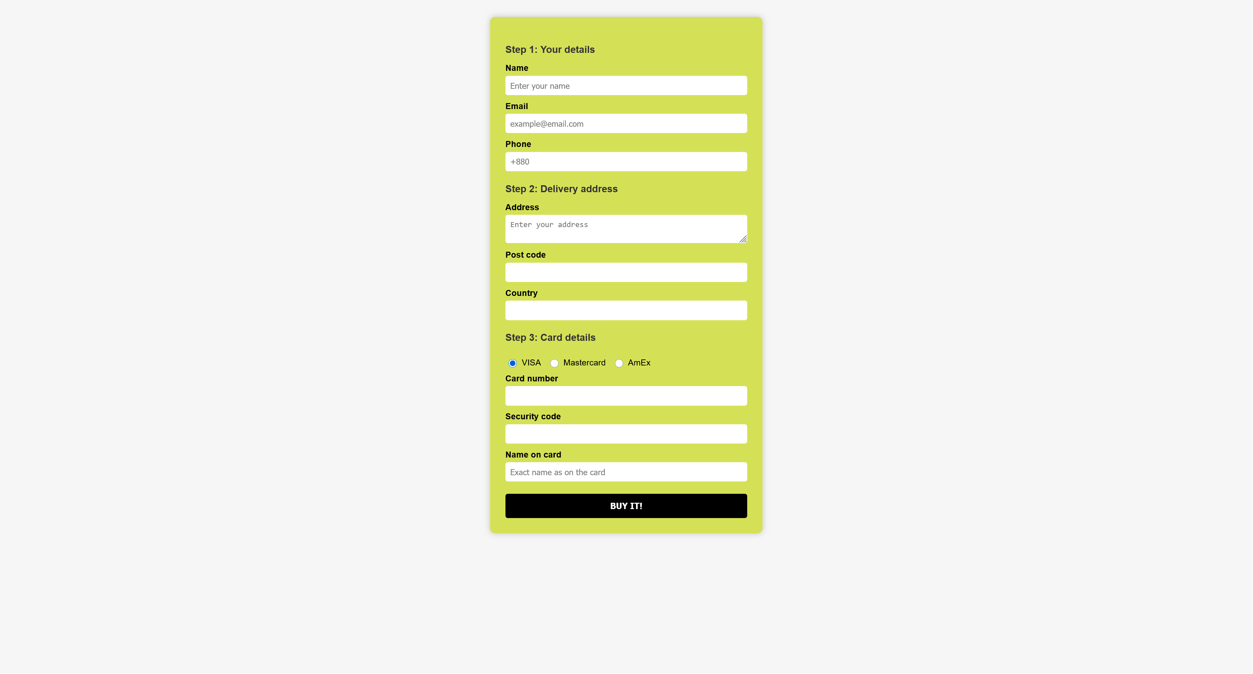
Fig 5.1: Light Version of the Website

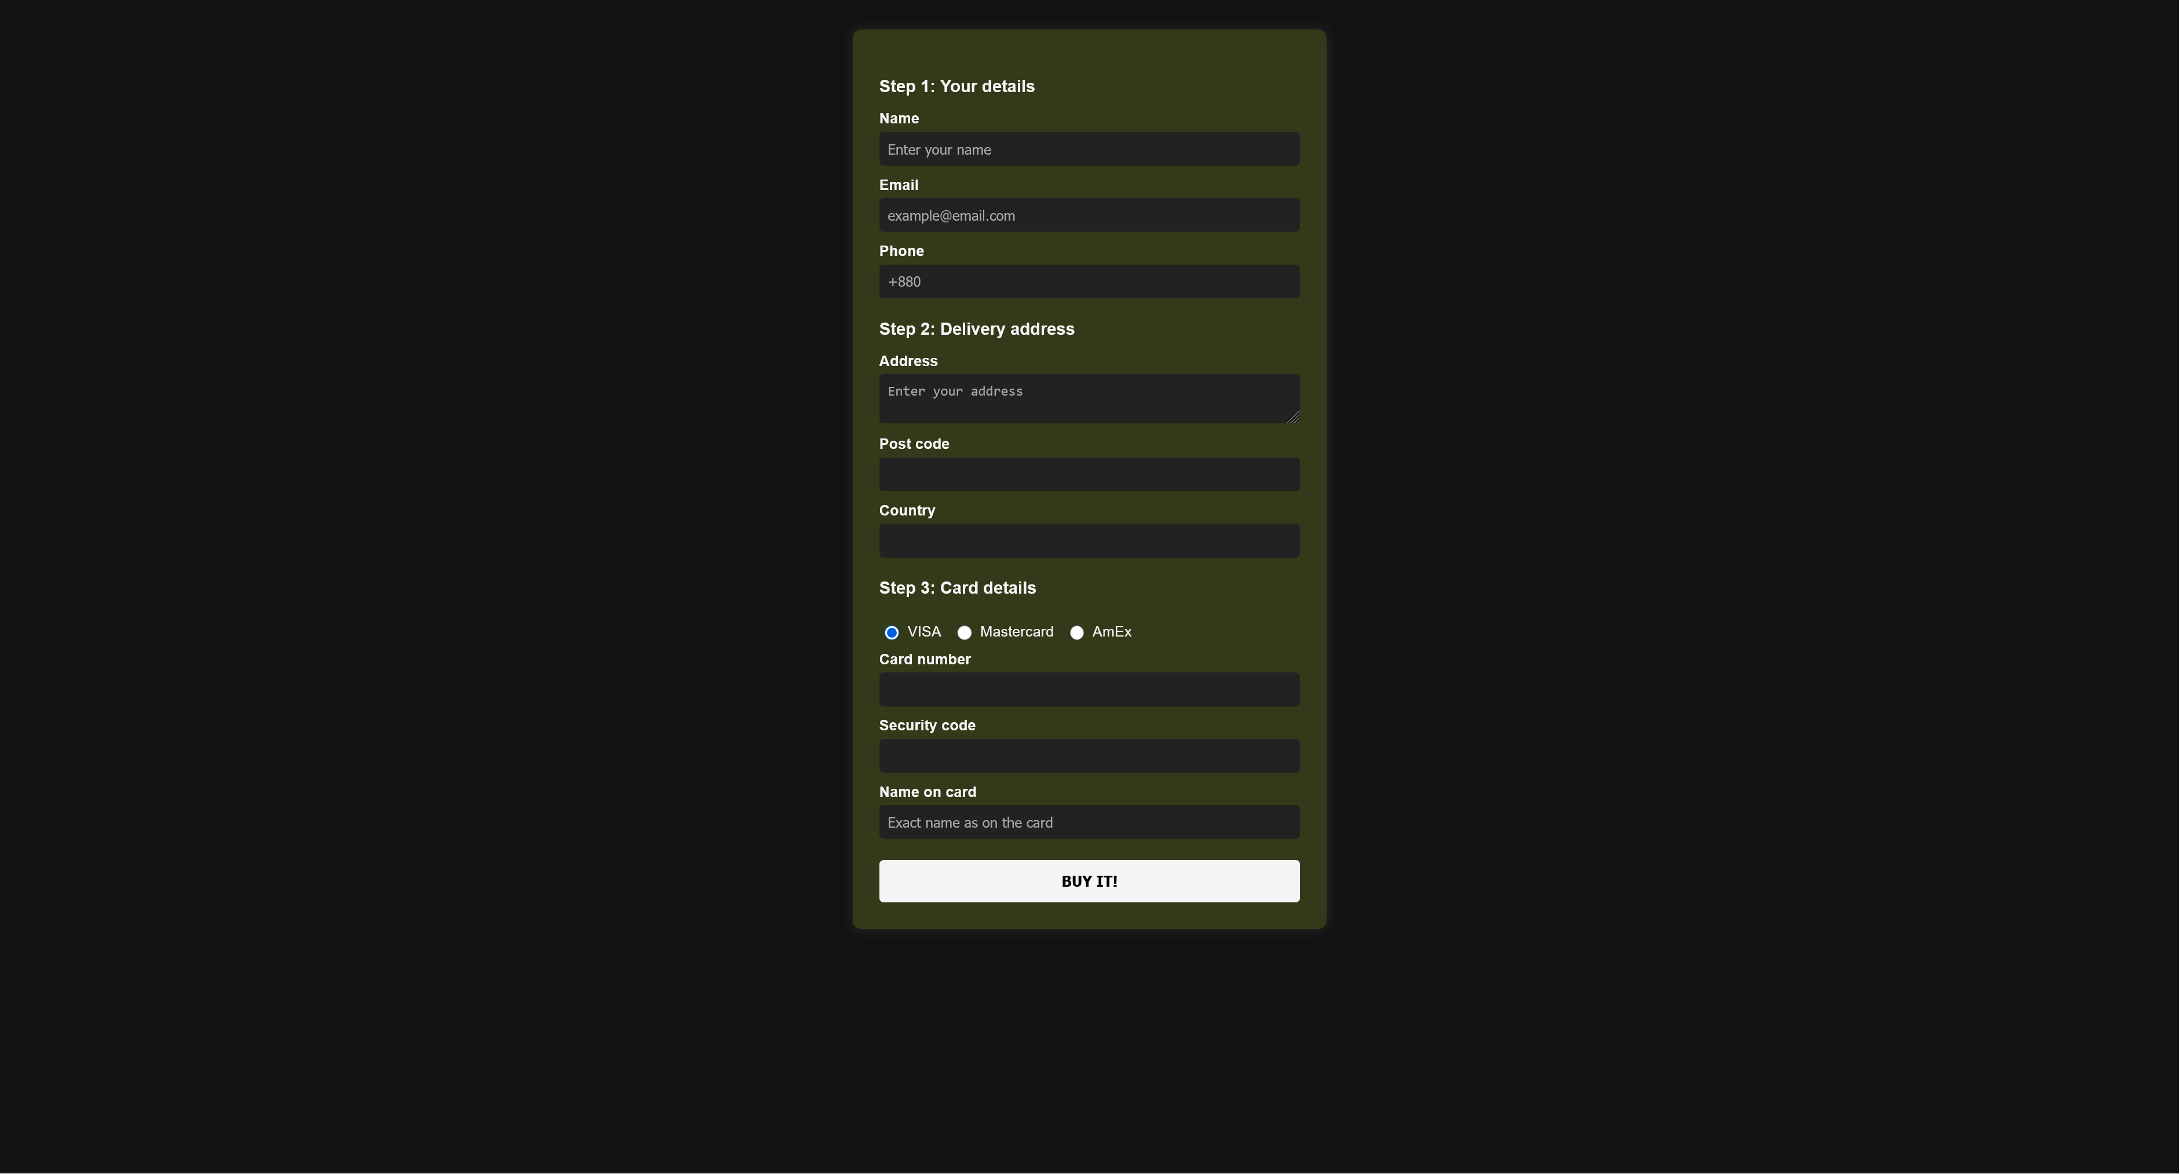
Fig 5.2: Dark Version of the Website

5.7 Discussion
The experiment was carried out to design and implement a structured multi-step web form with support for dark mode. The form was divided into three logical stages: user details, delivery address, and card details. By structuring the form in this way, the data collection process was made clearer and easier to follow.
The HTML elements such as <label>, <input>, and <textarea> were used to ensure proper semantic structure and accessibility. Labels were associated with inputs so that the form could be interpreted by screen readers, which improved accessibility.
In light mode, the form was styled with high-contrast text, a soft green-yellow background, and adequate spacing between elements. A hover effect was added to the submit button so that interaction feedback was provided to users. However, it was observed that relying only on light mode limited usability, particularly in low-light environments.
To address this issue, dark mode was implemented using the CSS media query @media (prefers-color-scheme: dark). This allowed the form to automatically adapt its colors based on the user’s system preference. In dark mode, darker backgrounds were applied, while text and input fields were styled with lighter colors to maintain visibility. Special care was taken to ensure that contrast ratios were preserved so that placeholders, labels, and inputs remained readable.
Through this implementation, it was demonstrated that user experience and comfort could be improved by incorporating dark mode. The experiment highlighted the importance of designing forms not only for functionality but also for accessibility and adaptability to different user environments.

